**Experiment No: 9**

**Title:** Simple prototype for Expert System.

**Objective:** Understanding the composition of expert system for a given prototype

**Theory:**

Expert systems are the computer applications developed to solve complex problems in a particular domain, at the level of extra-ordinary human intelligence and expertise. They are one of the prominent research domains of AI. It is introduced by the researchers at Stanford University, Computer Science Department.

# General Characteristics of Expert Systems

* High performance
* Understandable
* Reliable
* Highly responsive

# Capabilities of Expert System

The expert systems are capable of

* Advising
* Instructing and assisting human in decision making
* Demonstrating
* Deriving a solution
* Diagnosing
* Explaining
* Interpreting input
* Predicting results
* Justifying the conclusion
* Suggesting alternative options to a problem

They are incapable of:

* Substituting human decision makers
* Possessing human capabilities
* Producing accurate output for inadequate knowledge base
* Refining their own knowledge

# General Components of Expert Systems

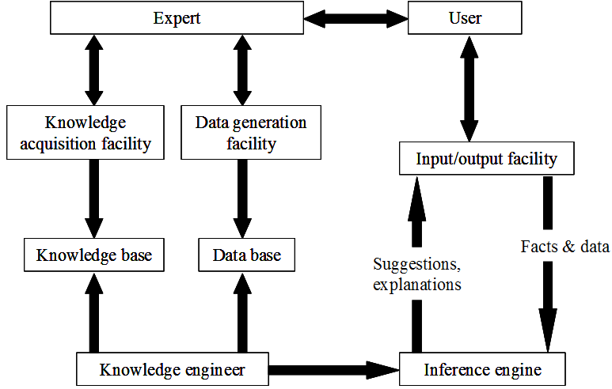

General components of Expert System

# Knowledge Base: It contains domain-specific and high-quality knowledge. Knowledge is required to exhibit intelligence. The success of any ES majorly depends upon the collection of highly accurate and precise knowledge.

# Components of Knowledge Base

The knowledge base of an ES is a store of both, factual and heuristic knowledge.

* **Factual Knowledge** − It is the information widely accepted by the Knowledge Engineers and scholars in the task domain.
* **Heuristic Knowledge** − It is about practice, accurate judgment, one’s ability of evaluation, and guessing.

# Knowledge representation: It is the method used to organize and formalize the knowledge in the knowledge base. It is in the form of IF-THEN-ELSE rules.

Knowledge Acquisition: The success of any expert system majorly depends on the quality, completeness, and accuracy of the information stored in the knowledge base.

The knowledge base is formed by readings from various experts, scholars, and the Knowledge Engineers. The knowledge engineer is a person with the qualities of empathy, quick learning, and case analyzing skills.

He acquires information from subject expert by recording, interviewing, and observing him at work, etc. He then categorizes and organizes the information in a meaningful way, in the form of IF-THEN-ELSE rules, to be used by interference machine. The knowledge engineer also monitors the development of the ES.

# General Inference Engine: Use of efficient procedures and rules by the Inference Engine is essential in deducting a correct, flawless solution. In case of knowledge-based ES, the Inference Engine acquires and manipulates the knowledge from the knowledge base to arrive at a particular solution.

In case of rule based ES, it

* + Applies rules repeatedly to the facts, which are obtained from earlier rule application.
  + Adds new knowledge into the knowledge base if required.
  + Resolves rules conflict when multiple rules are applicable to a particular case.

To recommend a solution, the Inference Engine uses the following strategies −

* **Forward Chaining**: It is a strategy of an expert system to answer the question, **“What can happen next?”**

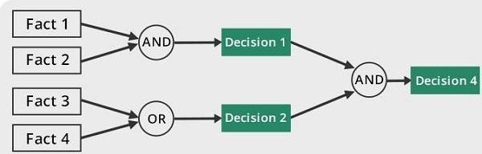

Forward Chaining in ID3

Here, the Inference Engine follows the chain of conditions and derivations and finally deduces the outcome. It considers all the facts and rules, and sorts them before concluding to a solution.

This strategy is followed for working on conclusion, result, or effect. For example, prediction of share market status as an effect of changes in interest rates.

* **Backward Chaining**: With this strategy, an expert system finds out the answer to the question, **“Why this happened?”**

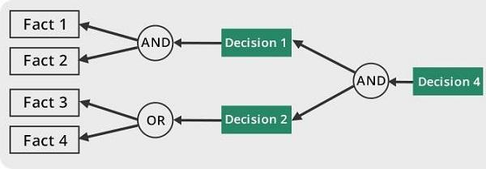

Backward Chaining in ID3

On the basis of what has already happened, the Inference Engine tries to find out which conditions could have happened in the past for this result. This strategy is followed for finding out cause or reason. For example: diagnosis of blood cancer in humans.  
  
This concludes the inference engine part. The next component is User interface.

**User Interface:** User interface provides interaction between user of the ES and the ES itself. It is generally Natural Language Processing so as to be used by the user who is well-versed in the task domain. The user of the ES need not be necessarily an expert in Artificial Intelligence.

It explains how the ES has arrived at a particular recommendation. The explanation may appear in the following forms:

* Natural language displayed on screen.
* Verbal narrations in natural language.
* Listing of rule numbers displayed on the screen.

# Requirements of Efficient ES User Interface

* It should help users to accomplish their goals in shortest possible way.
* It should be designed to work for user’s existing or desired work practices.
* Its technology should be adaptable to user’s requirements; not the other way round.

# Benefits of Expert Systems

* **Availability** − they are easily available due to mass production of software.
* **Less Production Cost** − Production cost is reasonable. This makes them affordable.
* **Speed** − they offer great speed. They reduce the amount of work an individual puts in.
* **Less Error Rate** − Error rate is low as compared to human errors.
* **Reducing Risk** − they can work in the environment dangerous to humans.
* **Steady response** − they work steadily without getting motional, tensed or fatigued.

# Expert Systems Limitations

No technology can offer easy and complete solution. Large systems are costly; require significant development time, and computer resources. ES’s have their limitations which include

* Limitations of the technology
* Difficult knowledge acquisition
* ES are difficult to maintain
* High development costs

# Applications of Expert System

Design Domain:

* Camera lens design
* Automobile design.

Medical Domain:

* Diagnosis Systems to deduce cause of disease from observed data
* Conducting medical operations on humans.

Monitoring Systems:

* Comparing data continuously with observed system
* Prescribed behavior such as leakage monitoring in long petroleum pipeline.

Process Control Systems:

* Controlling a physical process based on monitoring.

Knowledge Domain:

* Controlling a physical process based on monitoring

Finance/Commerce:

* Detection of possible fraud
* Suspicious transactions
* Stock market trading
* Airline scheduling
* Cargo scheduling

**Post Lab Assignment:**

1. What is the domain of the expert system, and what knowledge is required to develop it?

The most important applied area of AI is the field of expert systems. An expert system (ES) is a knowledge-based system that employs knowledge about its application domain and uses an inferencing (reason) procedure to solve problems that would otherwise require human competence or expertise. The power of expert systems stems primarily from the specific knowledge about a narrow domain stored in the expert system's knowledge base.

It is important to stress to students that expert systems are assistants to decision makers and not substitutes for them. Expert systems do not have human capabilities. They use a knowledge base of a particular domain and bring that knowledge to bear on the facts of the particular situation at hand. The knowledge base of an ES also contains heuristic knowledge - rules of thumb used by human experts who work in the domain.

Knowledge Representation and the Knowledge Base

The knowledge base of an ES contains both factual and heuristic knowledge. Knowledge representation is the method used to organize the knowledge in the knowledge base. Knowledge bases must represent notions as actions to be taken under circumstances, causality, time, dependencies, goals, and other higher-level concepts.

Several methods of knowledge representation can be drawn upon. Two of these methods include:

1. Frame-based systems

- are employed for building very powerful ESs. A frame specifies the attributes of a complex object and frames for various object types have specified relationships.

2. Production rules

- are the most common method of knowledge representation used in business. Rule-based expert systems are expert systems in which the knowledge is represented by production rules.

A production rule, or simply a rule, consists of an IF part (a condition or premise) and a THEN part (an action or conclusion). IF condition THEN action (conclusion).

The explanation facility explains how the system arrived at the recommendation. Depending on the tool used to implement the expert system, the explanation may be either in a natural language or simply a listing of rule numbers.

1. What is the purpose of the expert system, and what problems does it aim to solve?

The purpose of an expert system is to provide computer-based assistance for decision-making, problem-solving, and knowledge representation in a specific domain. Expert systems aim to solve problems that require specialized knowledge and expertise, where human experts are not always available or accessible.

Expert systems can perform tasks such as diagnosis, classification, planning, design, and prediction, and can be used in various fields, including medicine, finance, engineering, law, and education. By capturing and organizing the knowledge of domain experts, expert systems can provide accurate and consistent advice, reduce errors and variability in decision-making, and improve efficiency and productivity.

Generic Categories of Expert System Applications

Table 11.1 outlines the generic areas of ES applications where ES can be applied. Application areas include classification, diagnosis, monitoring, process control, design, scheduling and planning, and generation of options.

Classification - identify an object based on stated characteristics

Diagnosis Systems - infer malfunction or disease from observable data

Monitoring - compare data from a continually observed system to prescribe behaviour

Process Control - control a physical process based on monitoring

Design - configure a system according to specifications

Scheduling & Planning - develop or modify a plan of action

Generation of Options - generate alternative solutions to a problem

1. What is the knowledge representation method used by the expert system, and how is the knowledge base structured?

The knowledge representation method used by an expert system typically depends on the type and complexity of the domain and the knowledge required to solve the problem. Some common methods of knowledge representation include rule-based systems, frames, semantic networks, and Bayesian networks.

Rule-based systems are the most widely used method of knowledge representation in expert systems. In this approach, the knowledge base is structured as a collection of if-then rules, which specify the conditions that must be met to apply a particular solution or action. For example, a rule-based system for medical diagnosis might contain rules such as "If the patient has a fever and a sore throat, then diagnose as strep throat".

Frames are a knowledge representation method that captures the hierarchical relationships between objects or concepts in a domain. Each frame contains attributes that describe the object, as well as slots that specify the values of those attributes. Frames are often used in expert systems for natural language understanding, where the system must interpret the meaning of words and phrases in context.

Semantic networks are a graphical representation of knowledge that captures the relationships between concepts in a domain. In a semantic network, nodes represent concepts, and edges represent the relationships between them. Semantic networks are often used in expert systems for knowledge organization and retrieval, where the system must match a user's query to relevant concepts in the knowledge base.

Bayesian networks are a probabilistic model that represents the relationships between variables in a domain. Each variable is represented as a node in the network, with edges indicating the dependencies between variables. Bayesian networks are often used in expert systems for prediction and decision-making tasks, where the system must estimate the probability of a particular outcome given a set of input variables.

The knowledge base of an expert system is structured according to the chosen method of knowledge representation. The knowledge base typically contains a collection of facts, rules, and procedures that represent the knowledge of domain experts. The knowledge base may be stored in a database or other data structure that allows for efficient access and retrieval of information. The structure of the knowledge base is designed to facilitate the inference and decision-making processes of the expert system, allowing it to provide accurate and effective advice to users.